© Jurnal Nasional Teknik Elektro dan Teknologi Informasi
This work is licensed under a Creative Commons Attribution-ShareAlike 4.0 International License
DOI: 10.22146/jnteti.DOI number
Comparative Analysis of Machine Learning Models for Palestine Genocide Sentiment
Wafa Tsabita¹, Afrida Helen², Mira Suryani²
¹ Padjadjaran University, Sumedang, 45363, Indonesia
² Department of Computer Science, Faculty of Mathematics and Natural Sciences, Padjadjaran University, Jatinangor, Sumedang, Indonesia
[Received: DD MM YY, Revised: 1 January 2025, Accepted: 1 February 2025]
Corresponding Author: Author Name (email: author@institution.com)

ABSTRACT — Social media platforms such as X have become major spaces for public discussion of global humanitarian issues, including the Palestinian genocide. The presence of organized information campaigns, commonly known as Hasbara projects, has intensified online discourse and contributed to information warfare through the dissemination of misleading and biased content. The large volume and complexity of such user-generated data make manual analysis impractical, this requiting automated sentiment classification approaches. This study aims to compare the performance of machine learning models in classifying sentiments of tweets related to the Palestinian genocide on media social X. A total 1.702 tweets collected between October 2012 and April 2025 were categorized into three sentiment classes pro, neutral and anti-genocide. Data preprocessing included case folding, noise removal, stopword removal, tokenization, lemmatization, and stemming. Feature extraction was conducted using Term Frequency-Inverse Document Frequency (TF-IDF) and Word2Vec. The evaluated models were Naïve Bayes, Support Vector Machine, Long Short-Term Memory, and Bidirectional Long Short-Term Memory, with hyperparameter fine-tuning applied. The results show that the SVM model achieved the best overall performance, with an accuracy of 85,97% and an f1-score of 85,88%. However, deep learning models, particularly LSTM dan BiLSTM, demonstrated stronger capability in capturing complex contextual sentiment patterns. In conclusion, SVM is the most effective model for this dataset, while deep learning approaches offer promising potential for handling mode complex sentiment representation in future studies.
KEYWORDS — Sentiment Analysis, Machine Learning, Deep Learning, Social Media X, Palestinian Genocide, Text Classification.
Table I
Font Size Details
Font Type | Font Size | Font Style
 |  | Regular | Bold | Italic
Helvetica | 7 | Figure caption | Figure label
 | 9 | Heading level 3 | List of author names, abstract heading, heading level 1, heading level 2, | Heading level 2
 | 20 |  | Title
Times New Roman | 7 | Author affiliation
 | 8 | Table caption (in small caps), reference items, | Table header, table subheader | Table subheader
 | 9 | Cell in tables
 | 10 | Abstract content, body paragraph

- INTRODUCTION
This document is a template. An electronic copy that can be downloaded from the website of Jurnal Nasional Teknik Elektro dan Teknologi Informasi UGM. For any questions about writing guideline, please contact Jurnal Nasional Teknik Elektro dan Teknologi Informasi editorial team via email, as shown on the website. Information about paper submission is also available on the Jurnal Nasional Teknik Elektro dan Teknologi Informasi UGM website (https://jurnal.ugm.ac.id/v3/JNTETI/).
- METHODOLOGY
The easiest way to meet the requirement of writing format is by using this document as a template, and then type your text into it.
Page size must fit the A4 page size, which is 210 mm (8.27") wide and 297 mm (11.69") length. Margin limits are set as below:
- Top = 23 mm (0.90")
- Bottom = 18 mm (0.70")
- Left = right = 13 mm (0.51")
Article writing must be in two-column format with a space of 7.1 mm (0.28") between columns.
- PAGE STYLE
All paragraphs must be well organized and must be justified, meaning that the paragraphs must be aligned evenly along the left and right margins.
- DOCUMENT LETTERS
Body paragraph must be in Times New Roman or Times font. Type 3 font may not be used. Another font type can be used if needed for special purpose. Font size features can be seen in Table I.
- TITLE AND AUTHOR
The title must be in Helvetica, 20-point font. Author’s name must be in Helvetica, 9-point font. The maximum words number for the title is 12 words.
Title and author name must be in a double column format and left-aligned. Each initial letter of words in the title must be in uppercase, except for particles, prepositions, and conjunctions such as “a/an,” “and,” “in/on/at,” “by,” “for,” “from,” “or,” and its kind. Author’s name writing may not indicate a position (e.g., Supervisor lecturer), an academic degree (e.g., Dr.) or membership from any professional organization (e.g., IEEE Senior Member).
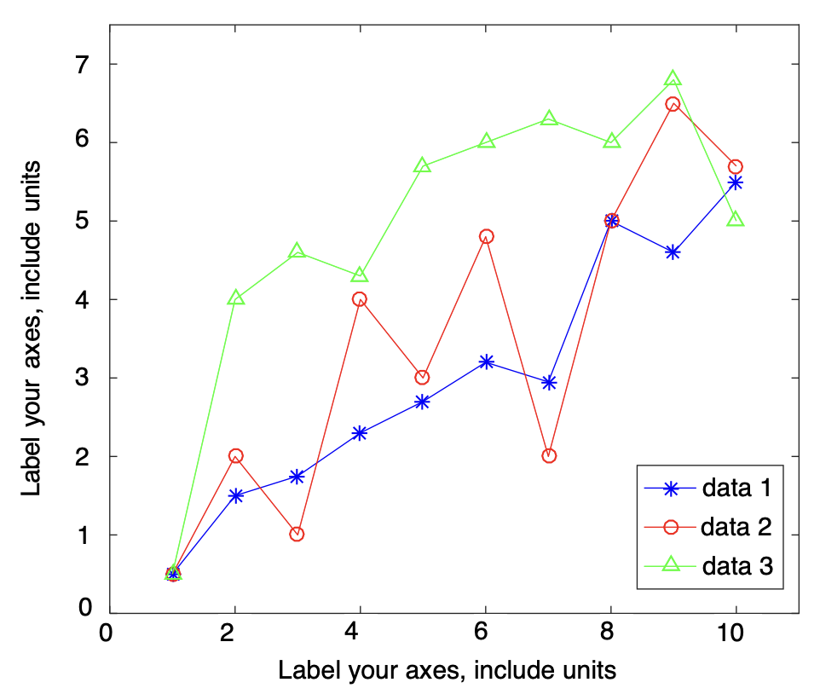
Figure 1. Example of line chart with well contrast color on the computer screen.

(a)
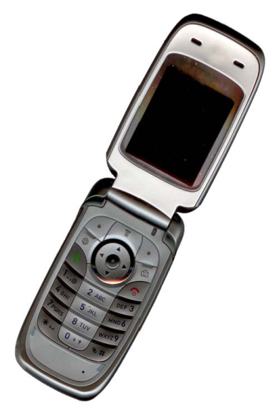
(b)
Figure 2. Example of image with different resolutions, (a) in low resolution, (b) in high resolution.

Every affiliation must be included, at least company and country name of the author (for example: SWA Medical Centre Pty Ltd, INDONESIA). In the manuscript, email address is required for the corresponding author.
Under author and affiliation information, the received date specifies the date the manuscript passes the initial screening and plagiarism check stage and is eligible for the review stage. The revised date indicates the date the author submits revision after the editorial decision. Meanwhile, accepted date indicates the letter of acceptance (LOA) issuance date.
- HEADING SECTION
We recommend that there are no more than 3 levels for heading. All headings must be in Helvetica, 9-point font. Each letter in the heading must be in uppercase.
- LEVEL 1 HEADING
Level 1 heading must be in uppercase, bold, left-aligned, and use Roman numerals as numbering. For example, see the “III. PAGE STYLE” heading from this document. Level 1 headings that are not preceded by a Roman numeral are Conflicts of Interest, Authors’ Contribution, Acknowledgment, References, and Appendix(es).
- LEVEL 2 HEADING
Level 2 heading must be in uppercase, bold, italics, left-aligned and numbered using uppercase alphabets. For example, you can see the heading of “C. HEADING SECTION” above.
- LEVEL 3 HEADING
Level 3 heading must in uppercase, left-aligned, and numbered with Arabic numbers followed by right parentheses. The contents of the level 3 section are under the heading title as a new paragraph. For example, this section starts with heading level 3.
- FIGURE AND TABLE
Table, figure, and chart must be at the top of the page. Large charts and tables can be stretched in both columns. Colored charts are permitted. Use solid color that contrasts well for display on the computer screen, as shown in Figure 1.
Figure 2(a) shows example of a low-resolution image that is not in accordance with the provisions, while Figure 2(b) shows an example of an image with sufficient resolution. Make sure that the image resolution is high enough so that the images’ details, such as texts in images, are visible. Please check all the images in your paper, ensure that:
- the color is in a high contrast,
- the image is clear,
- all the images’ texts are legible.
Typefaces and type sizes should be consistent in all your graphics and tables. The font used in graphics is Helvetica, while Times New Roman is used in tables. In graphics, the font size should appear approximately 8 points when displayed at full size, while for tables, it should be set to 9 points.
- FIGURE LABEL AND CAPTION
Figures are labeled with Arabic numerals. Figure label must be in bold and Helvetica, 7-point font. The single-line caption (e.g., Figure 1) is centered, while the multiline caption must be justified (e.g., Figure 2). Figure caption and label must be placed after the related image, as shown in Figure 2.
- TABLE LABEL AND CAPTION
Tables are labeled using uppercase Roman numerals. Table label is centered and must be in small caps and Times New Roman, 8-point font. Each initial letter of words in the table caption uses capital letters (except for particles, prepositions, and conjunctions as listed in section III B) and must be in small caps. Table caption is placed before the related table, as shown in Table I.
- FIGURE RESOLUTION AND COLOR
The proper resolution of your figures should be a minimum of 300 ppi. Figures in color are available in both online and printed versions.
- ABBREVIATIONS AND ACRONYMS
Define abbreviations and acronyms the first time they are used in the text, even after they have already been defined in the abstract. Abbreviations such as IEEE, AC, and DC do not have to be defined. Abbreviations that incorporate periods should not have spaces: write “C.N.R.S.,” not “C. N. R. S.” Do not use abbreviations in the title unless they are unavoidable.
- OTHER RECOMMENDATIONS
Use one space after periods and colons. Hyphenate complex modifiers: “zero-field-cooled magnetization.” Avoid dangling participles, such as, “Using (2), the distance was calculated.” It is not clear who or what used (2). Write instead, “The distance was calculated by using (2).”
A parenthetical statement at the end of a sentence is punctuated outside of the closing parenthesis (like this). In American English, periods and commas are within quotation marks, like “this period.” Other punctuation is “outside”! Avoid contractions; for example, write “do not” instead of “don’t.” The serial comma (Oxford comma) is preferred: “A, B, and C” instead of “A, B and C.”
Prefixes such as “non,” “sub,” “micro,” “multi,” and “ultra” are not independent words; they should be joined to the words they modify, usually without a hyphen. There is no period after the “et” in the Latin abbreviation “et al.”, which is also italicized. The abbreviation “i.e.,” means “that is,” and the abbreviation “e.g.,” means “for example” (these abbreviations are not italicized).
- LINKS AND BOOKMARKS
All hypertext links and bookmarks sections will be deleted. If the paper needs to refer to the email address or URL in the article, the full address or URL must be typed in a normal font.
- EQUATION WRITING
Number equations consecutively with equation numbers in parentheses flush with the right margin, as shown in (1) below. Separate the equation and its equation number using a tab space. Use the equation editor to make the equation. To tighten your equation, use the right slash sign (/), rank function, or appropriate rank. Use parentheses to avoid confusion in writing fraction number. Punctuate equations when they are part of a sentence.
$X\left(ω\right)=\int_{-∞}^{∞}{{x\left(t\right)∙e}^{-jωt} dt}.$ (1)
Make sure that the symbols in the equation have been defined before the equation or follow the equation directly after it appears. Symbols are typed in italics (T is for temperature, but T is for Tesla). When referring to an equation, write it as “(1),” not “Eq. (1),” or “equation (1),” except for the beginning of the sentence: “Equation (1) is …”
- PAGE NUMBERS, HEADERS, AND FOOTERS
Page Number, header, and footer will be added accordingly by the Jurnal Nasional Teknik Elektro dan Teknologi Informasi editorial team.
- REFERENCE SECTION
Title in Reference section may not be numbered. All reference items are in 8-point font. Please write each reference in accordance with each source category as listed in Reference section. Numbering of reference items is typed sequentially in square brackets (for example [1]).
References are written according to IEEE standards/styles. When you refer to a reference item, please use a reference number, for example “[2].” Do not use “Ref. [2]” or “Reference [2],” except for the beginning of the sentence, for example, “Reference [2] indicates that ...” In the use of several references, each number is typed with separate brackets (for example [2], [3], [4]-[6]). Some examples of reference items with different categories are shown in the References section which includes:
- example of book in [1],
- example of book series in [2],
- example of journal article in [3],
- example of seminar paper in [4],
- example of patent in [5],
- example of website in [6],
- example of a web page in [7],
- example of manual database in [8],
- example of datasheet in [9],
- example of master’s thesis in [10],
- example of technical reports [11], and
- example of standard in [12].
Please provide each reference item with DOI. Wikipedia, personal blog, and nonscientific websites must not be used as references. The main reference should be within the last five years and the minimum number of references is 20 with 80% of the total number of references being primary references. Tools such as Zotero, Mendeley, or EndNote may be used for reference management.
- CONCLUSION
Most of the formatting instruction in this document are adapted form IEEE Access article templates.
CONFLICTS OF INTEREST
Declare conflicts of interest or state “The authors declare no conflicts of interest.” Authors must identify and declare any personal circumstances or interest that may be perceived as inappropriately influencing the representation or interpretation of reported research results.
AUTHORS’ CONTRIBUTIONS
Authors must provide a short paragraph specifying their individual contributions. The following statements should be used: “Conceptualization, First and Second Author’s Name; methodology, First Author’s Name; software, First Author’s Name; validation, First, Second, and Third author’s Name; formal analysis, First Author’s Name; investigation, First Author’s Name; resources, First Author’s Name; data curation, First Author’s Name; writing—original draft preparation, First Author’s Name; writing—reviewing and editing, First Author’s Name; visualization, First Author’s Name; supervision, First Author’s Name; project administration, First Author’s Name; funding acquisition, Second Author’s Name,” etc. Authorship must be limited to those who have contributed substantially to the work reported.
ACKNOWLEDGMENT
Authors must acknowledge all parties involved in the research. The title for the acknowledgement and reference is not numbered.
REFERENCES
- M. Metev and P. Veiko, Laser Assisted Microtechnology, 2nd ed., R.M. Osgood, Jr., Ed. Berlin, Germany: Springer-Verlag, 1998, doi: 10.1007/978-3-642-87271-6.
- J. Breckling, Ed., The Analysis of Directional Time Series: Applications to Wind Speed and Direction, ser. Lecture Notes in Statistics. Berlin, Germany: Springer, 1989, Vol. 61, doi: 10.1007/978-1-4612-3688-7.ss
- S. Zhang, C. Zhu, J.K.O. Sin, and P.K.T. Mok, “A Novel Ultrathin Elevated Channel Low-Temperature Poly-Si TFT,” IEEE Electron Device Lett., Vol. 20, pp. 569–571, Nov. 1999, doi: 10.1109/55.798046.
- M. Wegmuller, J.P. von der Weid, P. Oberson, and N. Gisin, “Highresolution Fiber Distributed Measurements with Coherent OFDR,” Proc. ECOC’00, 2000, paper 11.3.4, pp. 109.
- R.E. Sorace, V.S. Reinhardt, and S.A. Vaughn, “High-Speed Digital-to-RF Converter,” U.S. Patent 5 668 842, Sept. 16, 1997.
- (2002) The IEEE website. [Online], http://www.ieee.org/, access date: 16-Sep-2014.
- M. Shell, (2002) IEEEtran homepage on CTAN. [Online], http://www.ctan.org/texarchive/macros/latex/contrib/supported/IEEEtran/, access date: 16-Sep-2014.
- FLEXChip Signal Processor (MC68175/D), Motorola, 1996.
- “PDCA12-70 data sheet,” Opto Speed SA, Mezzovico, Switzerland.
- A. Karnik, “Performance of TCP Congestion Control with Rate Feedback: TCP/ABR and Rate Adaptive TCP/IP,” Master’s thesis, Indian Institute of Science, Bangalore, India, Jan. 1999.
- J. Padhye, V. Firoiu, and D. Towsley, “A Stochastic Model of TCP Renocongestion Avoidance and Control,” Univ. of Massachusetts, Amherst, MA, CMPSCI Tech. pp. 99–02, 1999.
- Wireless LAN Medium Access Control (MAC) and Physical Layer (PHY) Specification, IEEE Std. 802.11, 1997.
APPENDIX (OPTIONAL)
Appendixes, if needed, appear after references. An appendix contains supplementary material that is not an essential part of the text itself but which may be helpful in providing a more comprehensive understanding of the research problem and/or is information which is too cumbersome to be included in the body of the manuscript. In addition, the appendix can also contain figures that are too large if placed in the body of a paragraph. The key point to remember when you are writing an appendix is that the information is non-essential; if it were removed, the manuscript would still be understandable.
It is appropriate to include appendix when the incorporation of material in the body of the work would make it poorly structured or it would be too long and detailed. In addition, the appendix is used to ensure inclusion of helpful, supporting, or essential material that would otherwise clutter or break up the narrative flow of the manuscript, or it would be distracting to the reader.

